**Testing Guidelines**

**Steps to run the application:**

**Precondition:** Below should be installed in your machine:

1. Git
2. Maven
3. Java
4. IntelliJ IDEA
5. Clone the repository from the link: <https://github.com/instanda-technicaltest/eShopOnWeb> in your system
6. Once clone is successful, navigate to eShopOnWeb folder and open the solution in Visual Studio
7. Open terminal 1 and go to the *PublicApi* folder and run command *dotnet run*
8. Open terminal 2 and navigate to *Web* folder and run *dotnet run --launch-profile Web*
9. Browse the application as *https://localhost:5001/*
10. Alternatively, you can try running the application using docker as mentioned in the repo link.

**Steps to run the tests:**

1. Open the terminal and change the directory to /eShopOnWeb/tests
2. Run the command: maven clean test

**Test Configuration:**

1. Language: Java
2. Automation Framework: Selenium
3. API Automation: Karate
4. Design Pattern: Page Object Model
5. Version Control: GitHub
6. Build Tool: Maven
7. BDD Framework Tool: Cucumber

The configuration to select browser is mentioned in the file ConfigFileReader.java present inside /main/java/DataProviders folder. The configuration can be modified to select different browsers.

Currently, the configuration is done to run the test cases in headless mode on Google chrome. This can be changed in the AllDriverManager.java file inside /Managers folder.

**Test Structure:** As part of testing, we have considered the application into components namely Login, Catalog, Cart and Checkout. The feature files are placed under */test/resources/features* folder.

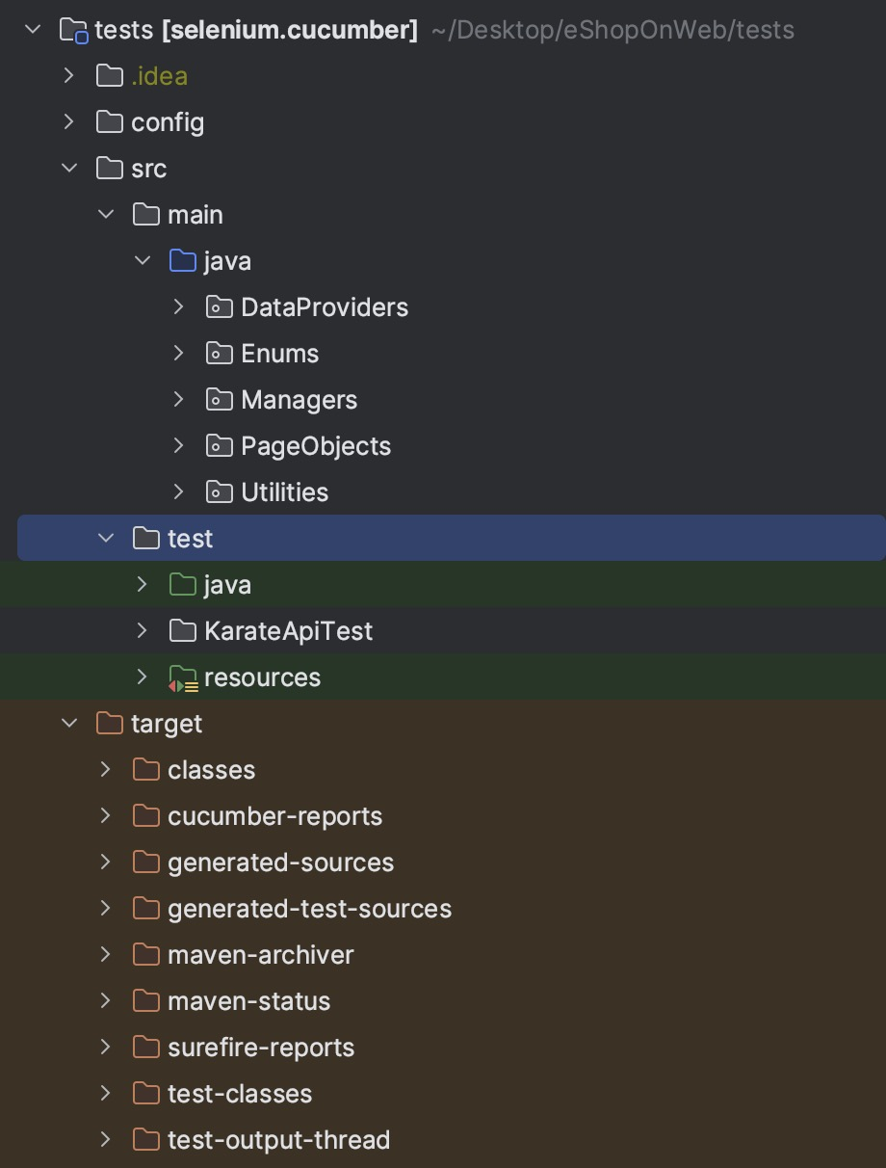

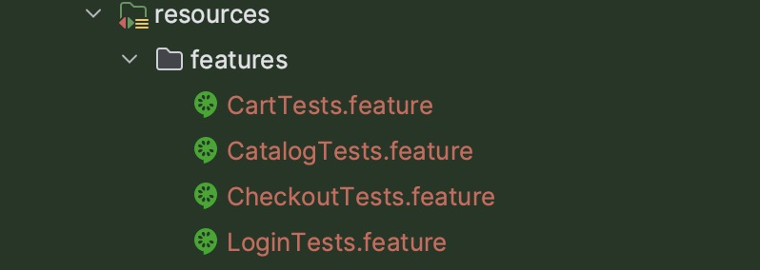

The step definitions are defined in */test/java/StepDefinitions*

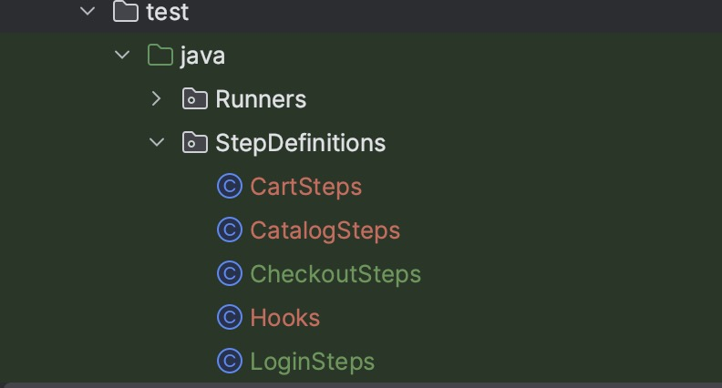

Corresponding page objects are placed in */main/java/PageObjects.*

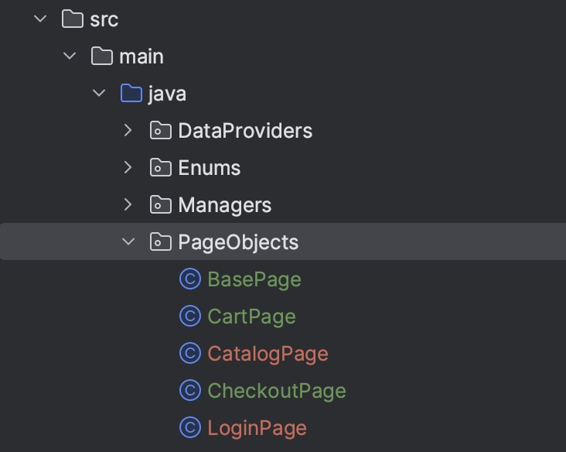

Also, Test Runner is situated inside */test/java/Runners*

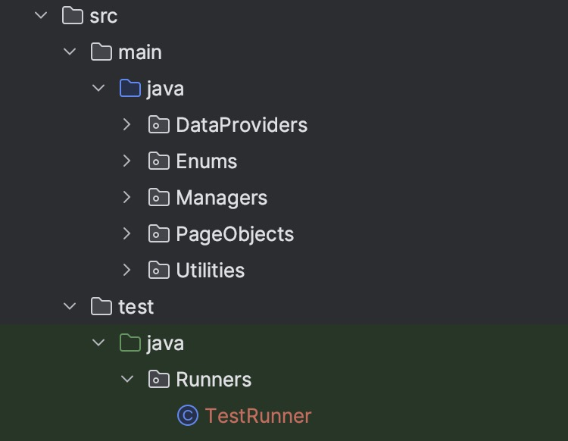

**Test Environment:** *https://localhost:5001/*

**Test Report:** Once the test runs, the report is generated inside the *tests/target/cucumber-reports/advanced-reports/cucumber-html-reports* folder.

Report Overview:   
 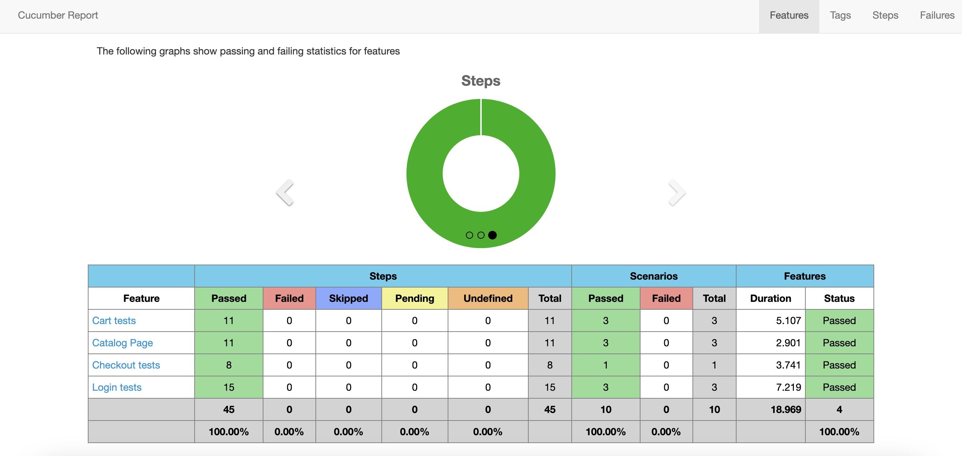

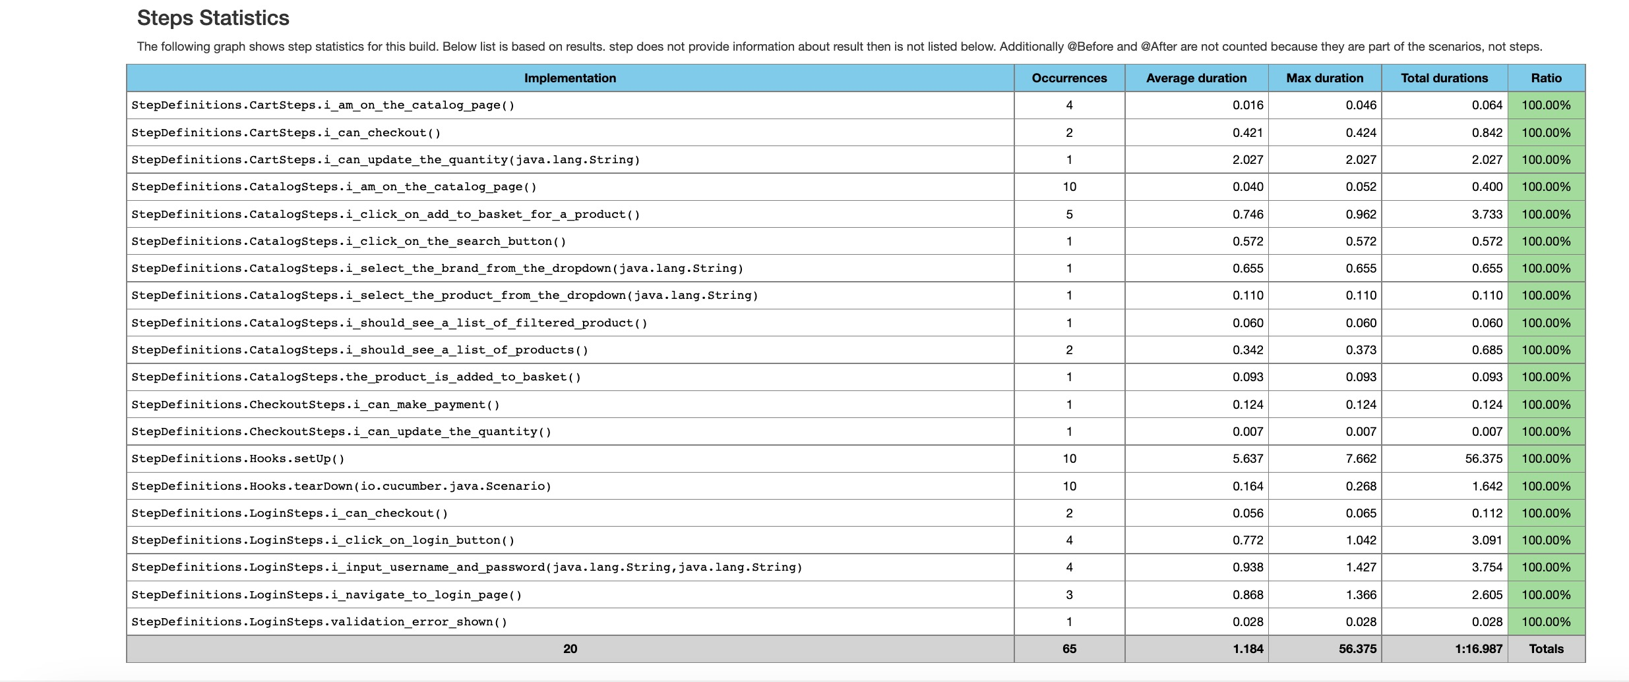

Catalog Feature Report:

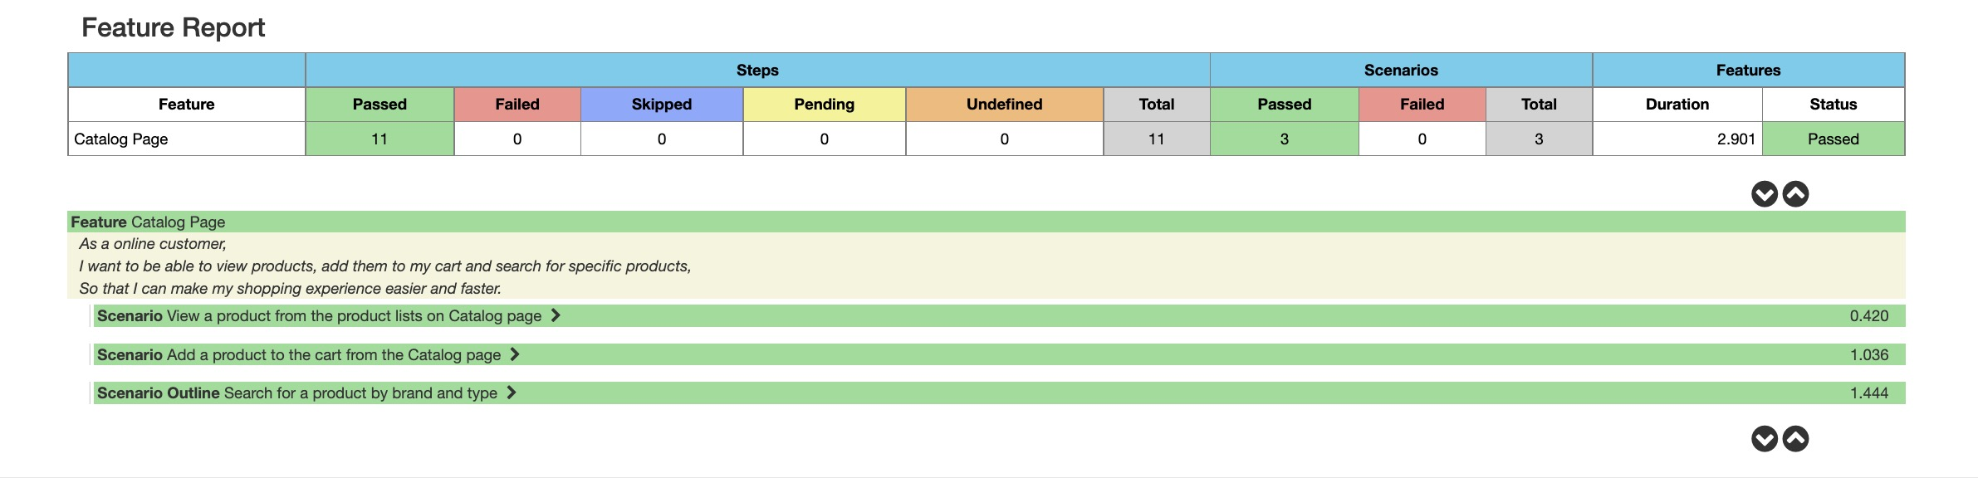

Checkout Feature Report:

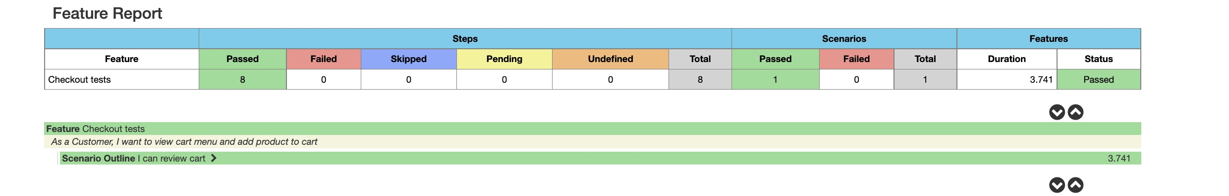

Login Feature Report:

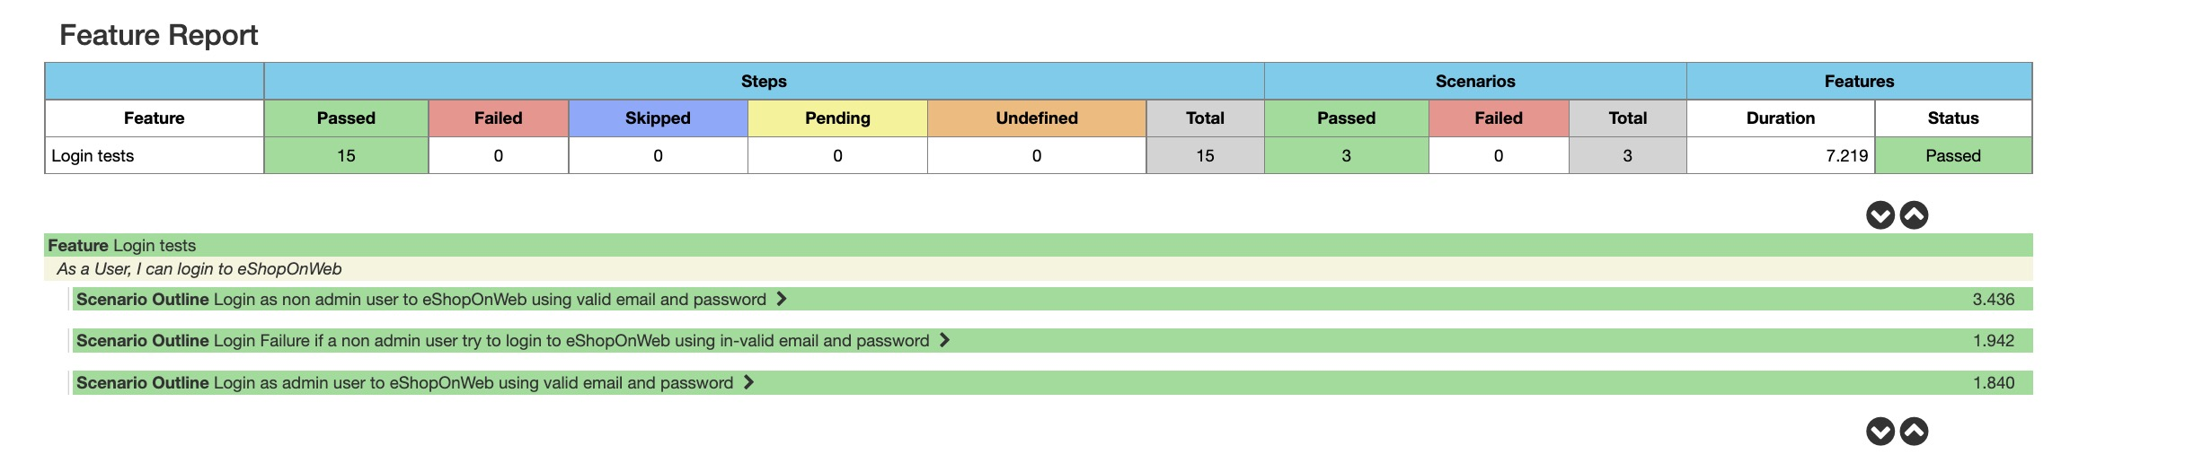

Cart Feature Report:

